FINAL EXAMINATION
TIME ALLOWED: 90’
Subject: Linear Algebra. No books allowed.

1/ Find all real value(s) m such that the matrix 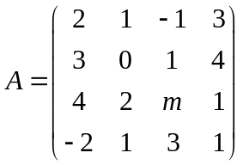 is invertible.

2/ Let and
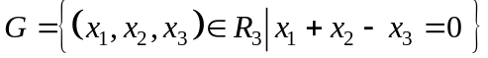 be two subspaces of a vector space 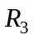.
Find one basic and a dimension of the intersection 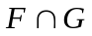.

3/ Given an inner product in as follow:
.
Let 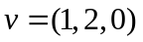 and 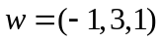 be two vectors of .
Compute the length of the vector 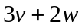.

4/ Let 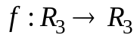 be a linear transformation.
Assume that .
a/ Compute 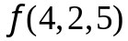.
b/ Find a dimension and one basic for 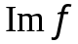.

5/ Let be a linear transformation and let 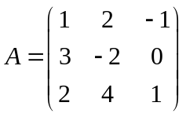 be a matrix of the
mapping 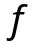in the basic 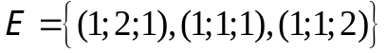. Find 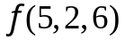.

6/ Determine all real value(s) m such that the number 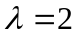 is an eigenvalue of the
matrix 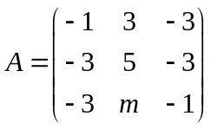.

7/ Make a change of variables that transforms the quadratic form
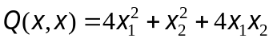 into the canonic form (using the orthogonal diagonalization method).
-----------------------  -----------------------

